|  |  |
| --- | --- |
|  | Requirement Specification |
|  |  |
|  | Ritvars Timermanis EC1401876  HND Software Development Y2  2/3/17 |

Contents

Statement of Work 3

Client Interview Q&A 3

Project Requirements 4

Project Aim and Objectives 4

Aim 4

Objectives 4

Persona 5

User Interface 5

Navigation 6

User Expectations 6

Use Case Diagram 7

Class Diagram 8

Wireframes 8

Colour Scheme 10

Hierarchy Map 10

User Requirements 10

Hardware 11

Software 11

Developer Requirements 11

Software 11

Hardware 11

Limitations 12

Context of Use 12

Feedback 12

Functional & Non-Functional Requirements 12

Functional 12

Authentication 12

Data sync 12

Administration 12

Legal requirements 12

Non-Functional 13

Scalability 13

Reliability 13

Security 13

Data Integrity 13

Usability 13

Maintainability 13

Research 13

Survey 14

Legal Considerations 14

Project Plan 15

Citations 17

Bibliography 17

Glossary of Terms 17

# Statement of Work

I’ve been tasked by ‘Simply Football’ fanzine that’s tracking ‘Peterhead FC’ in the Scottish Champions league to create a computerized system that allows their subscribers to see game details and fixtures, league details and player details within ‘Peterhead FC’. They also require the ability to store all subscriber details for legal reasons and to be able to send them relevant information.

Potential customers are likely to be ‘Peterhead FC’ fans and supporters.

It’s important that the computerised system is easy to use and accessible by younger and older people. Users must be able to use the computerized system from desktops and mobile phones / tablets.

I have decided that the computerized system will be a web app with front-end developed in HTML[1], JS[2] & PHP[3] and with backend developed in Python. I picked Python because it’s fast, simple to write and very effective. To make the web app responsive so it’s accessible from devices with varying screen sizes, I will be using Bootstrap framework for the front end. It’s important that the web app is accessible using most common internet browsers like:

* Chrome
* Firefox
* Opera
* Safari
* And the mobile equivalents of the browsers mentioned above

# Client Interview Q&A

* What kind of player data is to be displayed? (goals, assists etc.)
  + **Name, squad numbers, position, goals, bookings and send-offs.**
* What kind of features should the system have?
  + **League table, team table, login page.**
* How often does the data need to be updated?
  + **Weekly, but more often if possible.**
* How will members authenticate?
  + **Name, DoB, email and sub type**
* What user info will be stored?
  + **Name, DoB, email and sub type**
* Should advertisements be added to the system?
  + **Only for public (not required, but can be added)**
* What is meant by ‘partial’ and ‘full’ subscription?
  + **Partial – less info weekly (no videos or images)**
  + **Full – all the stuff (highlights, player profiles)**
* What kind of pages/sections should there be?
  + **Player profile, game records (league tables etc.).**
* Should there be a ‘pricing’ page?
  + **Can be, but not required**
* What kind of access will non-members have?
  + **Only homepage**

# Project Requirements

Pages required but are not limited to:

* **Home** page – navigation to the rest of the pages, short paragraph about ‘Peterhead FC’
* **League table** page – display the league table with scores
* **Player profiles** page – display player statistics
* **Login** page – allow existing subscribers to log on
* **Sign-up** page – allow people to sign-up and purchase a subscription

# Project Aim and Objectives

## Aim

This project aims to enable fans to keep up with ‘Peterhead FC’ news, their players and their statistics.

## Objectives

* Provide high quality user experience
* Eliminate quality problems – there is no shortage of systems like these, but my research has found that there is lack of high quality systems (read more in research section of this document).
* Increase revenue

# Persona

Blake is a director at ‘Johnsonyne’ and works every business day from 9-5. Blake is a hard-core ‘Peterhead FC’ fan who never misses a game. Blake enjoys playing video games as well.

**Name**: Blake Johnson

**Age**: 32

**Education**: BEng in Aerospace Engineering

**Marital and family status**: Single with no children

**Place of residence**: Edinburgh

**Employment**: Director at his own start-up ‘Johnsonyne’

**Characteristics and Interests**: Hard working, football fan and a video game enthusiast.

**Reasons for visiting the website**: To check on team scores

**Limitations**: Blake uses computers daily and can easily browse the web.

# User Interface

The solution will be a GUI (Graphical User Interface). The site will be using parallax scrolling which is a feature of Bootstrap framework. Primary navigation will be found on the index page, but the pages that require secure database access will be placed in separate files (login page, register page etc.). Since we are using a responsive framework the pages will scale depending on user’s device screen size. Users on the larger screens (desktops and laptops) will usually interact with the site using a mouse and a keyboard, but mobile/tablet users will do this using touchscreen.

Navigation will be left click based. As stated above, users on mobile devices will be using touchscreen to click, navigate and scroll. For the text fields a keyboard will be used, either a physical one or an on-screen keyboard for touchscreen devices.

The website will have a consistent look and feel, it will be intuitive and appealing to the user by using media elements and making the website look professional and trusting.

The system must be accessible to a wide range of user devices. Including users using different OS’s and a variety of browsers.

Each page of the site will use the same colour palette to unify the look of the site and to not confuse users.

## Navigation

Main navigation bar will be fixed at the top of the webpage taking up full width of the screen. As for the smaller screens where the whole navigation bar cannot fit there will be a button with dropdown menu instead. The navigation will consist of main links which are: Home, League Tables, Player Statistics, Login/Signup. The navigation bar will be in black colour with blue accents and white text.

## User Expectations

* Quick
  + **Expectations**: Users expect the web app to load quickly and can go from page to page without waiting for too long. It’s very likely that a lot of the website views will be from mobile devices such as smartphones and tablets. Because of this it’s likely that users will be using mobile data to browse the website.
  + **Design**: Mobile data is limited and costs money so the smaller the size the quicker and cheaper it is for the user.
* Intuitive
  + **Expectations**: Links within the website must be intuitive by allowing the user to understand, follow and use the links with ease.
  + **Design**: Simple and easily recognisable menus with a separate button to take them back to home page.
* Buttons
  + **Expectations**: Buttons need to be noticeable and distinguishable from the rest of the content. On mobile devices, there’s no such function available that enables the user to hover over the links and buttons and highlight them.
  + **Design**: Follow the colour scheme, but make buttons easily distinguishable from the rest of the content.
* Colours
  + **Expectations**: Appealing to the users eye and should mix well together, but leaving plenty of contrast.
  + **Design**: Use a uniform colour scheme throughout the site.
* Typography
  + **Expectations**: Font that’s easy to read and size that is pleasant to the users eyes.
  + **Design**: Website will be using open-sans font. It’s easy on the eye and scales very well based on what device you’re viewing from (mobile / desktop)

## Use Case Diagram

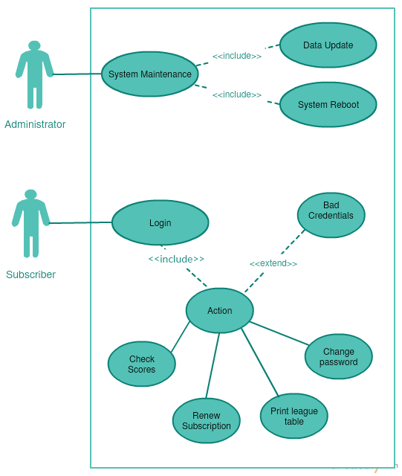

The methods used will mainly be handled by the Python webserver stored in ‘.py’ files. For logging in and registration Python webserver will work in conjunction with MariaDB server to pull/push the data to/from.

## Class Diagram

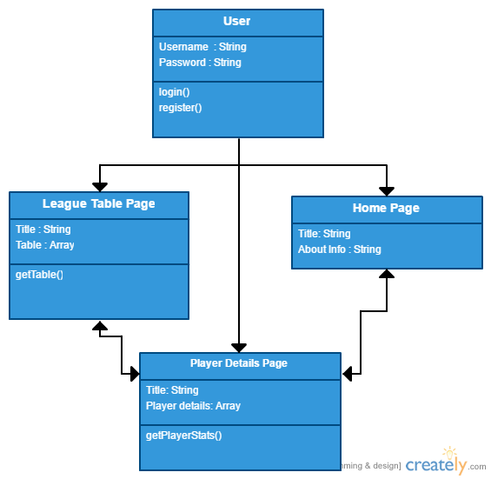

## Wireframes

Since we’ll be using a responsive framework (‘Bootstrap’), the site will support a lot of resolutions and scale up/down depending on the screen size.

Homepage

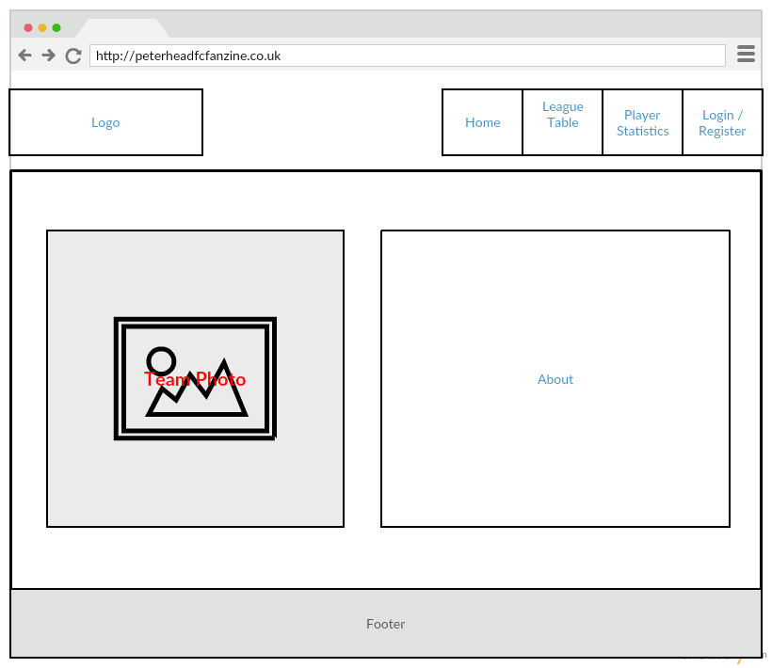

This is the planned layout for the landing page (homepage) with the team photo on the left and few paragraphs about the team on the right.

League Table / Player statistics page

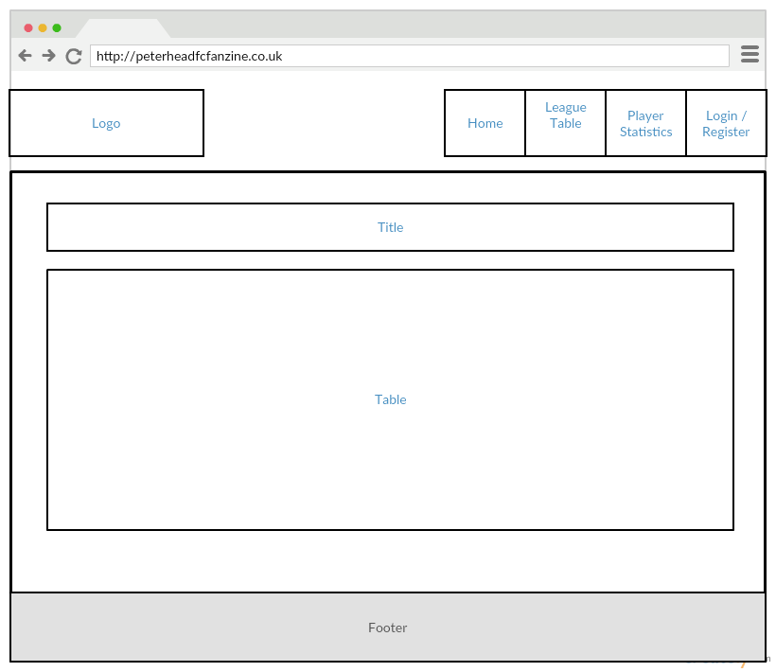

Login/Register page

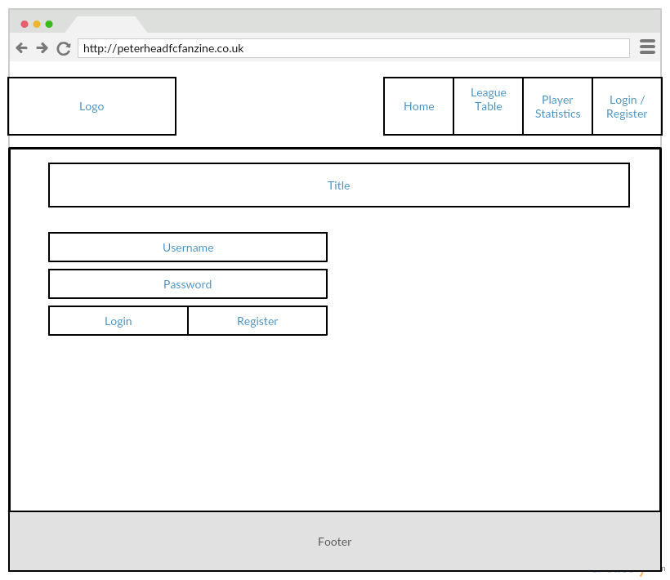

## Colour Scheme

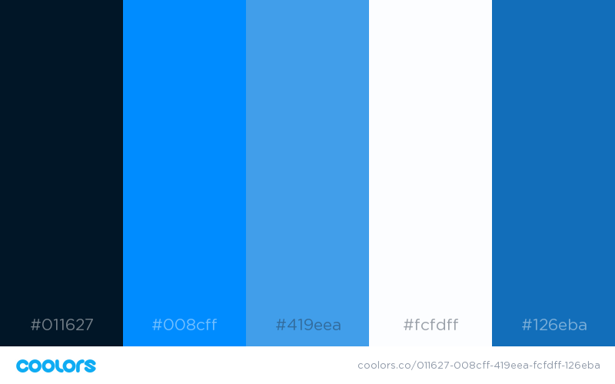

A simple colour palette has been chosen for the website with the most dominant colour being bark blue. The colour scheme is easy on the eyes and makes the content very readable and easy to see. The colour scheme also matches the ‘Peterhead FC’ team colours.

## Hierarchy Map

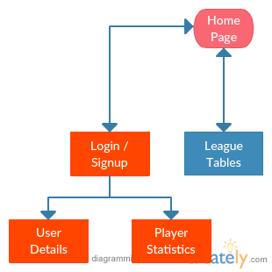

# User Requirements

* Predictable navigation
  + Top of the page
  + Meaningful page names
  + Easy to find information about ‘Peterhead FC’
  + Easy to find information about league and player statistics
  + Easy to find game timetable

## Hardware

Device with an internet connection and can run a modern web browser with support for JavaScript and HTML5 (Chrome, Firefox etc.). List of some of the devices that will work:

* Desktop computer
* Laptop
* Mobile device (smartphone, tablet etc.)
* Game console (while not recommended, should work fine)
* Internet connection (4G, LTE etc.)

## Software

Since the subscribers will be using internet to access this web app, these are the following software requirements:

* Web browser (Chrome, Firefox, Internet Explorer etc.)
* Operating System capable of running the web browser mentioned above

# Developer Requirements

## Software

Software that will be used to develop this project:

* Microsoft Word (to create the project documentation)
* Microsoft Project (to create a project plan)
* Atom Editor (to write Python code in)
* Python 3.6
* MariaDB (to store user data, league tables, etc)
* WinSCP (to upload files to webserver)
* Creately (to create diagrams)
* phpMyAdmin (to manage data stored in MariaDB)

## Hardware

Minimum hardware requirements for this project:

* Intel Consumer Desktop Chipset 2nd Generation processors and newer
* 8GB RAM
* USB Keyboard/Mouse interface
* At least 50GB disk space
* Internet connection
* Monitor

## Limitations

Internet is required to develop this project. If there’s an outage then no work can be done due to the connection required to the server.

# Context of Use

A lot of user traffic is to be expected. Usage of the site will vary a lot depending on the users, but they should be able to access the site and view league tables at any time. The administrator will have access to manage user data (access to database).

# Feedback

Users will require a convenient way to input text with validation so the users receive feedback about what have they done wrong. Depending on the page user will receive feedback for any actions that they have done wrong.

# Functional & Non-Functional Requirements

|  |  |
| --- | --- |
| Functional | Non-Functional |
| Authentication | Scalability |
| Data sync[4] | Reliability |
| Administration | Security |
| Legal requirements | Data Integrity |
|  | Usability |
|  | Maintainability |

## Functional

Authentication – The system needs to sign user in if credentials match with ones stored in DB[5].

Data sync – The system needs to sync league data from BBC Sports or another site (TBD[6]).

Administration – The system needs to allow site administrators (or editors) to view user data and manage the site.

Legal requirements – The system must not break DPA[7], CDPA[8] or any other laws.

## Non-Functional

Scalability – The system needs to be implemented in a way that’s easy to scale up in the future if necessary.

Reliability – The system needs to be reliable and stable, so users can browse the site without any issues.

Security – The system needs to protect user data and prevent unauthorized access.

Data Integrity – The data system displays needs to be genuine and true.

Usability – The system needs to convenient and comfortable for the user to use. Disabled and older people should be taken in mind as well when developing this system.

Maintainability – The system needs to be developed in a way that allows it to be easily maintained in the future. Example - Relative links[9] should be used when possible. “If links are internal to a site, the use of relative links makes the site easily portable. If links are external, they must be frequently checked to make sure that the link can still be traversed.” ((NIST), 2002)

# Research

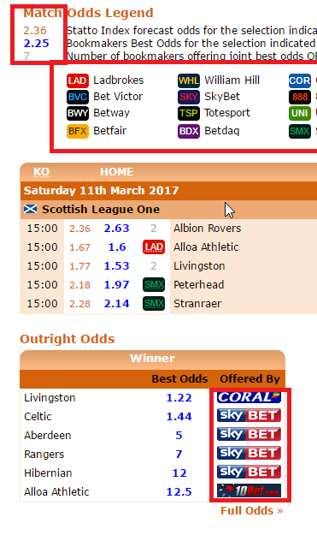I conducted research for this project throughout the whole planning stage. One of the problems I discovered while researching other websites that keep track of player statistics and scores was the fact that these sites were not responsive and looked outdated (Example - <http://www.statto.com/football/ratings/scotland/league-one>), while the site is functional it’s hard to browse using mobile and looks quite old.

Figure 1

Another issue I found out while researching similar websites was that most of them are gambling orientated with odds and links to betting sites. We want to avoid this because we do not endorse gambling (Example – *See Figure 1* - <http://www.statto.com/football/odds/scotland/league-one>)

## Survey

I conducted a survey to gather more information about user preferences. The survey itself is available here <https://goo.gl/8W0j9m> and the results can be viewed here <https://goo.gl/UyTvWg>.

From the results gathered at the time of writing I’ve reached following conclusions:

* Majority of surveyed people are willing to pay (71.4%) for a subscription from £5 to £10 (42.9%)
* Most popular platform between surveyed people is Windows (57.1%)
* All the surveyed people would like to receive weekly updates (100%) by e-mail newsletter (57.1%)

## Legal Considerations

The system must conform to requirements of disability discrimination legislation (e.g. DDA — Disability Discrimination Act 1995). The system will be required to store personal information of its users and it will be required to store information that would be subject to the Data Protection Act 1998.

# Project Plan

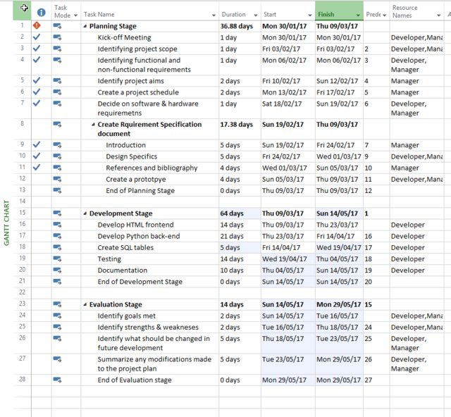

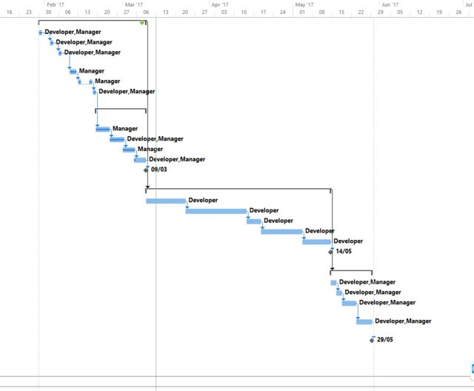

# Citations

(NIST), N. I. o. S. a. T., 2002. *Maintainability.* [Online]   
Available at: http://zing.ncsl.nist.gov/WebTools/WebSAT/maintenance.shtml  
[Accessed 10 March 2017].

# Bibliography

League tables - <http://www.bbc.co.uk/sport/football/scottish-league-one/table?print=true>

Python 3.6 - <https://www.python.org/downloads/>

MariaDB - <https://mariadb.org/>

Diagram creator - <https://creately.com/>

File transfer tool between the client and server - <https://winscp.net/eng/download.php>

Code editor - <https://atom.io/>

PHP based access to the database - <https://www.phpmyadmin.net/downloads/>

# Glossary of Terms

|  |  |  |
| --- | --- | --- |
| DB |  | Acronym for “Database” |
| Sync |  | Short for “synchronisation” |
| TBD |  | Acronym for “to be determined” |
| DPA |  | Acronym for “Data Protection Act” |
| CDPA |  | Acronym for “Copyright, Designs and Patents Act” |
| Link |  | In this documents context – “hyperlink” |

1. Hyper Text Markup Language
2. JavaScript
3. Hypertext Preprocessor
4. Synchronisation
5. Database
6. To Be Determined
7. Data Protection Act 1998
8. Copyright, Designs and Patents Act 1988
9. Hyperlinks